Explorers - A Further Venture into the Creator's Minds for a Greater Understanding of Their "Project Earth Plan of Salvation"

ICTN 6815 Fall 2020 Network Media Services Fall Project

BioBattle – Team Collaboration Document

"The Project Team" | Jeremy Hopkins - Code Developer | Mark Little - Project Manager | Steven Bartshe - Graphics Designer | Virgil Moffett - Testing & Documentation

Contents

8-26-2020 2

New Group Membership: Project Team 2 2

8-31-2020 2

Please advise as to when you would like to meet and begin discussions of our project. 3

9-6-2020 3

Here are some interesting games that may serve as a model for what we do 3

9-9-2020 3

9-11-2020 4

9-14-2020 4

9-18-2020 4

9-19-2020 5

9-23-2020 5

9-24-2020 5

Check the teams site for the agenda of what we discussed this week 5

9-29-2020 5

10-3-2020 6

10-3-2020 7

monday.com Team 7

10-4-2020 7

10-8-2020 7

10-9-2020 9

10-10-2020 9

10-11-2020 10

New version published. 10

10-13-2020 11

Attached a screenshot that has the help menu showing 11

10-18-2020 13

10-21-2020 13

10-22-2020 14

10-23-2020 14

10-24-2020 14

10-26-2020 15

Microsoft Teams meeting 15

10-29-2020 15

11-4-2020 15

11-5-2020 16

11-6-2020 18

11-10-2020 19

Hit F12 to go to developer tools 20

Yes – working great – except I have a huge “loss of life” 24

Game Design Artwork – Mark Little 9-28-2020 25

Game Design 25

Name 25

Core Concept/Plot 25

Characters 26

Location 26

Mechanics/features of gameplay 26

Genre 26

Artwork 26

# 8-26-2020

## New Group Membership: Project Team 2

You've been added to a new group for the course 2020 Fall Network Media Services *601*.

The name of the group is Project Team 2.

=======================================================================

# 8-31-2020

Mark Little posted a new comment on the thread Project Team Discussions for Project Team 2:

My email address is littlema20@students.ecu.edu. I look forward to working with everyone.

Team members:

Please advise as to when you would like to meet and begin discussions of our project. Thanks.

-Mark Little

=======================================================================

# 9-6-2020

Mark Little posted a new comment on the thread Project Team Discussions for Project Team 2:

Here are some interesting games that may serve as a model for what we do:

PixelDefense: You have to place the towers in the specified places to prevent the incoming monsters from entering your homeland. https://www.edopedia.com/demo/pixeldefense

Mimstris: You have to quickly arrange the falling blocks of different shapes to fill the horizontal line similar to the video game Tetris. https://mimstris.surge.sh/

Tower Building Game: Your task is to drop the blocks on top of each other and make your way towards the skies. http://fe.bmqb.com/tower_game/index.html

Clumsy Bird: The game works by you controlling a flying character and the mission is to successfully pass it from in-between the incoming walls without hitting them. http://ellisonleao.github.io/clumsy-bird/

Radius Raid: A shooting game where players need to shoot at relentless enemies and destroy them before the enemy ships destroy you. http://js13kgames.com/games/radius-raid/index.html

BreakLock: You need to connect the dots in order to match the lock pattern and win. https://maxwellito.github.io/breaklock/

=======================================================================

# 9-9-2020

Steven Bartshe posted a new comment on the thread Project Team Discussions for Project Team 2:

Good morning, team.

I’m open to anything. I don’t want to bite off more than we can chew so understanding our skill levels/experience may be good. I do have experience with HTML and CSS. As for JavaScript , I haven’t studied much on it. I have used it but have only grabbed scripts from the Internet and adapted it to my needs.

I don’t have much game development experience, except in Flash, back in the day.

My email is bartshes16@students.ecu.edu

Which vehicle is the best to communicate with everyone on the team? Is email best or would this discussion thread be best ?

Looking forward to working with you all! Steve

=======================================================================

# 9-11-2020

Jeremy Hopkins posted a new comment on the thread Project Team Discussions for Project Team 2:

Hey all. I'm open to whatever for communications, but am somewhat partial to Teams as it offers a much cleaner communications channel along w/ file sharing, task lists, etc. for us. That said, my email is hopkinsje09@students.ecu.edu.

As I was reading some of Mark's examples, one i though of which reminded me of the Tower Game is an arcade game called "Stack 'Em" I think. It's very similar.

I also agree w/ Steven that I don't want to tackle something that's way beyond our ability to pull it off. I don't think we're needing to invent a best seller here, but if we do, I'd gladly participate in all the profits. :)

What do y'all think about using Teams? I'd be happy to go ahead and create the team and get everyone joined in.

=======================================================================

# 9-14-2020

Mark Little posted a new comment on the thread Project Team Discussions for Project Team 2:

Would everyone be available for a Microsoft Teams meeting on 9/22 at 6pm?

Mark Little posted a new comment on the thread Project Team Discussions for Project Team 2:

I have created a Microsoft Team environment for us.

=======================================================================

# 9-18-2020

Would everyone be available for a Microsoft Teams meeting on 9/22 or 9/23 at 6pm? Thanks.

-Mark Little

From: Hopkins, Jeremy <hopkinsje09@students.ecu.edu>

Sent: Friday, September 18, 2020 12:20 PM

To: Little, Mark Douglas <littlema20@students.ecu.edu>; Bartshe, Steven <bartshes16@students.ecu.edu>; Moffett, Virgil Dean, Sr <moffettv20@students.ecu.edu>

Subject: Re: ICTN 6815: Project Team 2

I can do the 22nd, but not the 23rd.

=======================================================================

# 9-19-2020

Mark Little posted a new comment on the thread Project Team Discussions for Project Team 2:

I have created a Microsoft Team meeting request for 9/22 at 6pm. Look forward to brainstorming ideas with everyone. Thanks

=======================================================================

# 9-23-2020

From: Bartshe, Steven <bartshes16@students.ecu.edu>

Sent: Wednesday, September 23, 2020 9:27 PM

To: Little, Mark Douglas <littlema20@students.ecu.edu>; Moffett, Virgil Dean, Sr <moffettv20@students.ecu.edu>; Hopkins, Jeremy <hopkinsje09@students.ecu.edu>

Subject: Re: ICTN 6815: Project Team 2

I couldn’t make the 22nd. Are we having a second meeting on the 29th?

Thank you,

Steve

=======================================================================

# 9-24-2020

Hi Steve,

Yes, we are meeting again at 6pm on the 29th. It looks like we may be having weekly touch-base meetings.

Check the teams site for the agenda of what we discussed this week.

Thanks for checking in!

-Jeremy

=======================================================================

# 9-29-2020

From: Hopkins, Jeremy <hopkinsje09@students.ecu.edu>

Sent: Tuesday, September 29, 2020 9:12 PM

To: Little, Mark Douglas <littlema20@students.ecu.edu>; Moffett, Virgil Dean, Sr <moffettv20@students.ecu.edu>; Bartshe, Steven <bartshes16@students.ecu.edu>

Subject: Github for project

Hey folks, I'll add this to teams tomorrow, but I've created an initial github repo for our project at the following location:

https://github.com/hopkeno/ECU-ICTN6815-Group2

I went ahead and uploaded the images Mark put in teams. If you send me your github userid/email I can add you to the project.

Thanks!

=======================================================================

# 10-3-2020

From: Little, Mark Douglas <littlema20@students.ecu.edu>

Sent: Saturday, October 3, 2020 11:58 AM

To: Moffett, Virgil Dean, Sr <moffettv20@students.ecu.edu>; Bartshe, Steven <bartshes16@students.ecu.edu>; Hopkins, Jeremy <hopkinsje09@students.ecu.edu>

Subject: Team project graphics

I have uploaded the following, additional images to our MS Teams environment:

• I have uploaded versions of the corona spikes and RNA enzymes with transparent backgrounds (file names: “corona-1” and “RNA-1”).

• I have uploaded the following iterations of the background. Both of these have a width of 800 pixels for the play interface, which should work for our targeted devices of computer workstations and laptops. I have also added color to the Earth and corona star images, so they stand out a little more

o Horizontal orientation, with the Corona Star and Earth on the left and right sides ff the screen (file name: “Background-horizontal-corona-earth”

o Vertical orientation, with Corona Star and Earth at the top and bottom of the screen (file name: “Background-vertical-corona-earth”)

• If we want to include a visual indicator for the Jonas Salk RNA enzyme cannons, we may be able to add simple triangles around the bridge window. See sample image (file name: “RNA-enzyme-cannon”). These can be placed in horizontal or vertical positions. This would provide a clear space from which the enzymes will originate, just as the corona spikes will originate from the spikes on the corona star.

• The file “Background-horizontal-earth-strike” shows an example of how the Earth image may transform when struck by a corona spike.

• Finally, I have created a sample interface showing how we may show scores for each corona spike that is destroyed, as well as when a spike makes its way to Earth (file name: “Sample-score-interface”)

I look forward to talking with everyone on Thursday. Thanks.

=======================================================================

# 10-3-2020

Hi Virgil,

Mark Little accepted your invitation and joined the Students team.

Go ahead and invite more people to start being more productive together.

Cheers,

## monday.com Team

=======================================================================

# 10-4-2020

From: Hopkins, Jeremy <hopkinsje09@students.ecu.edu>

Sent: Sunday, October 4, 2020 8:58 PM

To: Little, Mark Douglas <littlema20@students.ecu.edu>

Cc: Moffett, Virgil Dean, Sr <moffettv20@students.ecu.edu>; Bartshe, Steven <bartshes16@students.ecu.edu>

Subject: Re: Team project graphics

Thanks Mark,

I’ll take a look at the new graphics tomorrow and add them into the working version of the game.

I’ve begun a bit of the work to kick us off and you can see where I am thus far at the following link

https://hopkinsje09.000webhostapp.com/biobattle/

Everything is keyboard controlled thus far.

Jeremy

=======================================================================

# 10-8-2020

From: Bartshe, Steven <bartshes16@students.ecu.edu>

Sent: Thursday, October 8, 2020 8:10 PM

To: Hopkins, Jeremy <hopkinsje09@students.ecu.edu>; Little, Mark Douglas <littlema20@students.ecu.edu>

Cc: Moffett, Virgil Dean, Sr <moffettv20@students.ecu.edu>

Subject: Re: Team project graphics

Good evening.

Did I miss the meeting this week? I checked teams on both Wednesday and today.

I have posted the storyboard. Please let me know if this would work and I can create a few actual artwork frames. The splash screens are optional. We can just put the level number on the main screen.

If that’s the case, I can design the main gameplay screen and see what you think.

Thank you,

Steve

Get Outlook for iOS

From: Hopkins, Jeremy <hopkinsje09@students.ecu.edu>

Sent: Thursday, October 8, 2020 9:51 PM

To: Bartshe, Steven <bartshes16@students.ecu.edu>; Little, Mark Douglas <littlema20@students.ecu.edu>

Cc: Moffett, Virgil Dean, Sr <moffettv20@students.ecu.edu>

Subject: Re: Team project graphics

No worries. Mark and I met at 6pm and went over a few graphics changes that I wanted to have him do.

I think the storyboard could be fun, I *think* I know how to work that into the game.

I’ve done a LOT since Mark and I talked earlier today. At this point I’d like for y’all to take a look and tell me what you think.

I’m totally open to feedback here, and I still have some work to do.

One fundamental question for you on game play..

• My thought was have the RNA shoot from the cannon towards the SARS Spike, but after playing it the way it is, I personally think it’s pretty challenging already with a just point/click based gameplay. Thoughts? It is certainly WAY easier on me to leave it as is, and we could do some other things instead (ie: storyboard, menu, stats, credits, more mobile friendly, etc)

There is obviously still work to do, but I personally feel like we’re off to a good start!

GitHub link (which has a link to the game if you scroll to the bottom and click BioBattle): https://github.com/hopkeno/ECU-ICTN6815-Group2

Game link: https://hopkinsje09.000webhostapp.com/biobattle/

--Jeremy

=======================================================================

# 10-9-2020

From: Bartshe, Steven <bartshes16@students.ecu.edu>

Sent: Friday, October 9, 2020 9:47 AM

To: Hopkins, Jeremy <hopkinsje09@students.ecu.edu>; Little, Mark Douglas <littlema20@students.ecu.edu>

Cc: Moffett, Virgil Dean, Sr <moffettv20@students.ecu.edu>

Subject: Re: Team project graphics

Good morning, Jeremy.

Thank you for your response. I was in teams and didn’t see any new meeting invitations nor did I see any teams meeting started. Do I show up within your team?

As for work, other than test the game, do you want me to provide anything else? Do you want to see the artwork for the gameplay screen? Do you have any questions/comments on the storyboard I provided?

Please advise .

Thank you,

Steve

From: Hopkins, Jeremy <hopkinsje09@students.ecu.edu>

Sent: Friday, October 9, 2020 12:05 PM

To: Bartshe, Steven <bartshes16@students.ecu.edu>; Little, Mark Douglas <littlema20@students.ecu.edu>

Cc: Moffett, Virgil Dean, Sr <moffettv20@students.ecu.edu>

Subject: Re: Team project graphics

I had trouble finding the meeting yesterday also, the link was in an email somewhere. No worries.

I like the storyboard and would love to add it in. I think you can move forward with those graphics/screens, at this point it would be super easy to add them in between levels.

=======================================================================

# 10-10-2020

From: Moffett, Virgil Dean, Sr

Sent: Saturday, October 10, 2020 8:16 AM

To: Hopkins, Jeremy <hopkinsje09@students.ecu.edu>; Bartshe, Steven <bartshes16@students.ecu.edu>; Little, Mark Douglas <littlema20@students.ecu.edu>

Cc: Moffett, Virgil Dean, Sr <moffettv20@students.ecu.edu>

Subject: Team project SARS Game

Good Morning Everyone – Virgil here,

So sorry I was out of the loop for a few days and also missed the Teams meeting. I got onto the game last night and loved it !! Great Covid-19 death star, artwork.

Q1 : Have the RNA shoot from the cannon towards the SARS Spike, but after playing it the way it is, I personally think it’s pretty challenging already with a just point/click based gameplay.

A1 : I too thought to shoot RNA from the cannon with cannon controls but I think your implementation is better. The other option would have been to have the cannon attached to earth and pivot towards the incoming SARS spikes, but that would take away from the Earth esthetics. Great Graphics ☺

Q2 : Mobile friendly ?

A2 : I like the mobility as the defender navigates to the incoming SARS pikes relying on the user’s dexterity.

Q3: Stats – Credits ?

A3 : I was way too busy responding to incoming SARS Spike to pay attention to my level or credits. I figured that I’d jumped to a new level when they started

coming at me faster.. I’d look down at the stats every so often once I realized what was happening. Every spike hit takes 50 lives…

Q4 : Is there a way to Pause the game then resume ?

A4 : I left the game do something and of course many Earthlings were dead and it was Game Over ☺

Kind Regards,

Virgil Moffett

=======================================================================

# 10-11-2020

From: Hopkins, Jeremy <hopkinsje09@students.ecu.edu>

Sent: Sunday, October 11, 2020 12:07 AM

To: Moffett, Virgil Dean, Sr <moffettv20@students.ecu.edu>; Bartshe, Steven <bartshes16@students.ecu.edu>; Little, Mark Douglas <littlema20@students.ecu.edu>

Subject: Re: Team project SARS Game

## New version published.

Biggest wins here are:

Hit Space to pause/resume (and start a new game)

Hit ? to bring up the cheat menu (and game debug options) – This is mainly so I can add some visuals to help with the coding

SARS spikes do not necessarily travel in a straight line horizontally anymore, they move towards their target.

length of game (shortened to 11 misses), this along with speed, etc can all easily be manipulated.

Still working on:

can we “shoot” the RNA towards the spikes

pausing at a “level up” event, so we can load a splash screen for Steven’s storyboard artwork

=======================================================================

# 10-13-2020

**From:** Hopkins, Jeremy <[hopkinsje09@students.ecu.edu](mailto:hopkinsje09@students.ecu.edu)>   
**Sent:** Tuesday, October 13, 2020 8:16 PM  
**To:** Moffett, Virgil Dean, Sr <[moffettv20@students.ecu.edu](mailto:moffettv20@students.ecu.edu)>; Bartshe, Steven <[bartshes16@students.ecu.edu](mailto:bartshes16@students.ecu.edu)>; Little, Mark Douglas <[littlema20@students.ecu.edu](mailto:littlema20@students.ecu.edu)>  
**Subject:** Re: Team project SARS Game

Pushed another new version this evening (v0.5)…

Attached a screenshot that has the help menu showing you the shortcut/cheat keys.

RNA is now shooting from the cannon, and there is a placeholder “level up” screen.

If possible, I’d like to meet either later this week on Thursday or we could push this to early next week (we have a lecture on Monday at 6pm, maybe right after?)

I’d like to get feedback from everyone and better plan out next steps.   I think the overall base of the game is probably done but there is certainly time for debugging and adding features.

Let me know when y’all are free to meet.

-Jeremy

From: Moffett, Virgil Dean, Sr

Sent: Tuesday, October 13, 2020 8:22 PM

To: Hopkins, Jeremy <hopkinsje09@students.ecu.edu>; Bartshe, Steven <bartshes16@students.ecu.edu>; Little, Mark Douglas <littlema20@students.ecu.edu>

Subject: RE: Team project SARS Game

Wow – you are a “programmer” !!!

More comments to come once I finish a new issue dropped on my late today from Management …

Kind Regards,

Virgil Moffett

=======================================================================

# 10-18-2020

From: Hopkins, Jeremy <hopkinsje09@students.ecu.edu>

Sent: Sunday, October 18, 2020 9:31 PM

To: Moffett, Virgil Dean, Sr <moffettv20@students.ecu.edu>; Bartshe, Steven <bartshes16@students.ecu.edu>; Little, Mark Douglas <littlema20@students.ecu.edu>

Subject: Re: Team project SARS Game

Anyone have thoughts on a meeting for this week? I’m not planning on coding anymore until we discuss and determine next steps

Jeremy

=======================================================================

# 10-21-2020

From: Bartshe, Steven <bartshes16@students.ecu.edu>

Sent: Wednesday, October 21, 2020 3:27 PM

To: Hopkins, Jeremy <hopkinsje09@students.ecu.edu>; Moffett, Virgil Dean, Sr <moffettv20@students.ecu.edu>; Little, Mark Douglas <littlema20@students.ecu.edu>

Subject: Re: Team project SARS Game

Good Afternoon.

Please see attached and let me know if this would be sufficient as a gameboard or if you would like to see something different.

Thank you,

Steve

From: Bartshe, Steven <bartshes16@students.ecu.edu>

Sent: Wednesday, October 21, 2020 6:42 PM

To: Hopkins, Jeremy <hopkinsje09@students.ecu.edu>; Moffett, Virgil Dean, Sr <moffettv20@students.ecu.edu>; Little, Mark Douglas <littlema20@students.ecu.edu>

Subject: Re: Team project SARS Game

Apparently, my attachment didn't send so I added it to Teams under Files -> Game-Graphics21OCT20.

I'm going to add some more, as I get them done.

=======================================================================

# 10-22-2020

From: Hopkins, Jeremy <hopkinsje09@students.ecu.edu>

Sent: Thursday, October 22, 2020 2:42 PM

To: Bartshe, Steven <bartshes16@students.ecu.edu>; Moffett, Virgil Dean, Sr <moffettv20@students.ecu.edu>; Little, Mark Douglas <littlema20@students.ecu.edu>

Subject: Re: Team project SARS Game

I certainly see the potential for this. I believe I understand how we’d go about injecting these into the game, but would like to better understand your vision here so we can put it in place properly. I also would like feedback on the existing game.

I’m putting in a meeting poll before for next Tuesday or Thursday (feel free to suggest other days/times, I can tell you I’m not available on Monday or Wednesday though). My weekends are kinda flexible if we’d rather meet over the weekend (I prefer not Friday or Saturday evening though), and I could potentially be available during the workday, but understand that might be hard for others.

=======================================================================

# 10-23-2020

From: Hopkins, Jeremy <hopkinsje09@students.ecu.edu>

Sent: Friday, October 23, 2020 9:28:54 AM

To: Moffett, Virgil Dean, Sr <moffettv20@students.ecu.edu>; Bartshe, Steven <bartshes16@students.ecu.edu>; Little, Mark Douglas <littlema20@students.ecu.edu>

Subject: Re: Team project SARS Game

Sorry, for the misfire here. I incidentally sent an invite w/ no attendees. I forwarded along a “reminder” that is w/ the correct FindTime poll.

The time slots are basically 6:30/7:00 - 9:00 on Tues or Thursday.

=======================================================================

# 10-24-2020

From: Bartshe, Steven <bartshes16@students.ecu.edu>

Sent: Saturday, October 24, 2020 8:02 PM

To: Hopkins, Jeremy <hopkinsje09@students.ecu.edu>; Moffett, Virgil Dean, Sr <moffettv20@students.ecu.edu>; Little, Mark Douglas <littlema20@students.ecu.edu>

Subject: Re: Team project SARS Game

I’m good with any time. We need to reconvene so we can wrap this up.

Thank you,

Steve

=======================================================================

# 10-26-2020

Re: Team project SARS Game

When : Thursday, October 29, 2020 8:00 PM-8:30 PM

## Microsoft Teams meeting

=======================================================================

# 10-29-2020

From: Bartshe, Steven <bartshes16@students.ecu.edu>

Sent: Thursday, October 29, 2020 12:21 PM

To: Hopkins, Jeremy <hopkinsje09@students.ecu.edu>; Moffett, Virgil Dean, Sr <moffettv20@students.ecu.edu>; Little, Mark Douglas <littlema20@students.ecu.edu>

Subject: Re: Team project SARS Game

Good afternoon.

What time are we meeting tonight? I saw a few times on the post

Thank you,

Steve

From: Hopkins, Jeremy <hopkinsje09@students.ecu.edu>

Sent: Thursday, October 29, 2020 12:26 PM

To: Bartshe, Steven <bartshes16@students.ecu.edu>; Moffett, Virgil Dean, Sr <moffettv20@students.ecu.edu>; Little, Mark Douglas <littlema20@students.ecu.edu>

Subject: Re: Team project SARS Game

I sent an invite for 8pm, everyone has accepted, so it should be on your calendar.

=======================================================================

# 11-4-2020

From: Bartshe, Steven <bartshes16@students.ecu.edu>

Sent: Wednesday, November 4, 2020 3:26 PM

To: Hopkins, Jeremy <hopkinsje09@students.ecu.edu>; Moffett, Virgil Dean, Sr <moffettv20@students.ecu.edu>; Little, Mark Douglas <littlema20@students.ecu.edu>

Subject: Re: Team project SARS Game

Good Afternoon, all.

Here is the artwork for the levels. Please let me know if this will work for you.

Thank you,

Steve

From: Bartshe, Steven <bartshes16@students.ecu.edu>

Sent: Wednesday, November 4, 2020 3:30 PM

To: Hopkins, Jeremy <hopkinsje09@students.ecu.edu>; Moffett, Virgil Dean, Sr <moffettv20@students.ecu.edu>; Little, Mark Douglas <littlema20@students.ecu.edu>

Subject: Re: Team project SARS Game

Also. Here is the "germ" if you want to use it instead of the dart.

=======================================================================

# 11-5-2020

From: Little, Mark Douglas <littlema20@students.ecu.edu>

Sent: Thursday, November 5, 2020 2:06 PM

To: Bartshe, Steven <bartshes16@students.ecu.edu>; Hopkins, Jeremy <hopkinsje09@students.ecu.edu>; Moffett, Virgil Dean, Sr <moffettv20@students.ecu.edu>

Subject: Re: Team project SARS Game

I like these level screens, and hope that Jeremy can add them to the current game without too much additional coding. I suggest we add these, along with the original drawing as a startup screen, then keep the current game interface showing COVID-19 virus and Earth, as seen from the bridge of the Jonas Salk. Having a digitally rendered background for the actual game helps to keep the online gaming feel.

Thanks.

From: Little, Mark Douglas <littlema20@students.ecu.edu>

Sent: Thursday, November 5, 2020 2:07 PM

To: Bartshe, Steven <bartshes16@students.ecu.edu>; Hopkins, Jeremy <hopkinsje09@students.ecu.edu>; Moffett, Virgil Dean, Sr <moffettv20@students.ecu.edu>

Subject: Re: Team project SARS Game

The darts are actually the protein spikes from the COVID-19 virus. I vote we keep them, along with the COVID-19 virus, to maintain the integrity of the game.

From: Bartshe, Steven <bartshes16@students.ecu.edu>

Sent: Thursday, November 5, 2020 2:26 PM

To: Little, Mark Douglas <littlema20@students.ecu.edu>; Hopkins, Jeremy <hopkinsje09@students.ecu.edu>; Moffett, Virgil Dean, Sr <moffettv20@students.ecu.edu>

Subject: Re: Team project SARS Game

Thank you for the response. Do you need anything else from me? Do we want to entertain a boss level or just run with what we got?

Please advise and I will draw a boss level, if desired.

Thank you,

Steve

From: Hopkins, Jeremy <hopkinsje09@students.ecu.edu>

Sent: Thursday, November 5, 2020 9:07 PM

To: Little, Mark Douglas <littlema20@students.ecu.edu>; Bartshe, Steven <bartshes16@students.ecu.edu>; Moffett, Virgil Dean, Sr <moffettv20@students.ecu.edu>

Subject: Re: Team project SARS Game

Still working to tie these together.

In the meantime, I want to ensure we have something ready to go to turn in and then we can expand/tweak from there.

From that perspective, I’ve just uploaded a new version based on our current design/platform that includes a title screen and some audio for when you shoot and when you hit a SARS spike.

Things I need from one of you:

• I’d like someone to find us a good background sound track we can loop for the title screen and during gameplay.

• Also, while you are sound hunting if you don’t like the effects I selected, that’s fine, feel free to find new ones and recommend. The “shot” and “hit” effects will need to be about a half second in length. I’m not in love with the ones I’ve selected, but they work, and I don’t want to spend cycles hunting down better sound effects.

• Maybe a “Game Over” effect and music? (I’m open to this one)

Other than a few sound effects, I think we leave this one as version 1, and then I will make some implementation options based on the additional content and comments we have had.

I personally think the drastic style difference between the drawings and the renderings will make the outcome if we interlace these less than desirable, but I’d happy to be wrong and will withhold final opinion on that until I’ve seen it.

I’m happy with our overall product personally, and as I’ve said, I know this is a solid A in the gradebooks as is.

--Jeremy

=======================================================================

# 11-6-2020

From: Hopkins, Jeremy <hopkinsje09@students.ecu.edu>

Sent: Friday, November 6, 2020 8:06 AM

To: Little, Mark Douglas <littlema20@students.ecu.edu>; Bartshe, Steven <bartshes16@students.ecu.edu>; Moffett, Virgil Dean, Sr <moffettv20@students.ecu.edu>

Subject: Re: Team project SARS Game

Alternate version with Steven’s gameboard ready at https://hopkinsje09.000webhostapp.com/biobattle2/

Additional audio files as mentioned below would still be good, along with one more for when the SARS spikes hit earth.

Haven’t worked on the mashup between the two yet, and again, I’m just skeptical due to style differences that it will look good.

But, I do have an idea of how we could essentially present either view as a theme on the start screen, so standby for that.

--Jeremy

From: Little, Mark Douglas <littlema20@students.ecu.edu>

Sent: Friday, November 6, 2020 2:50 PM

To: Hopkins, Jeremy <hopkinsje09@students.ecu.edu>; Bartshe, Steven <bartshes16@students.ecu.edu>; Moffett, Virgil Dean, Sr <moffettv20@students.ecu.edu>

Subject: Re: Team project SARS Game

Here are some possible sound clips from freesound.org

https://freesound.org/people/klavo1985/sounds/485056/

https://freesound.org/people/Omar%20Alvarado/sounds/103216/

https://freesound.org/people/cydon/sounds/127706/

https://freesound.org/people/tfodor/sounds/253408/

=======================================================================

# 11-10-2020

**From:** Hopkins, Jeremy <hopkinsje09@students.ecu.edu>   
**Sent:** Tuesday, November 10, 2020 12:13 AM  
**To:** Little, Mark Douglas <littlema20@students.ecu.edu>; Bartshe, Steven <bartshes16@students.ecu.edu>; Moffett, Virgil Dean, Sr <moffettv20@students.ecu.edu>  
**Subject:** Re: Team project SARS Game

Awesome, I like that first one for in-game background music.

Here's what I put together to work with both of our themes..  Just click to select a theme to play:

[https://hopkinsje09.000webhostapp.com/biobattle3/](https://nam02.safelinks.protection.outlook.com/?url=https%3A%2F%2Fhopkinsje09.000webhostapp.com%2Fbiobattle3%2F&data=04%7C01%7Cmoffettv20%40students.ecu.edu%7C4a566e2150d7403efcef08d885375c97%7C17143cbb385c4c45a36ac65b72e3eae8%7C0%7C0%7C637405820110737708%7CUnknown%7CTWFpbGZsb3d8eyJWIjoiMC4wLjAwMDAiLCJQIjoiV2luMzIiLCJBTiI6Ik1haWwiLCJXVCI6Mn0%3D%7C1000&sdata=lQQ4cRUQsrRajhqrvdHxAjgBunegvfP9gfQeNYn%2FzI0%3D&reserved=0)

Also, this is a reminder that we agreed to meet on Tuesday @ 6pm.  I've scheduled that meeting for our Teams channel.

-Jeremy

**From:** Moffett, Virgil Dean, Sr   
**Sent:** Tuesday, November 10, 2020 3:23 PM  
**To:** Hopkins, Jeremy <hopkinsje09@students.ecu.edu>; Little, Mark Douglas <littlema20@students.ecu.edu>; Bartshe, Steven <bartshes16@students.ecu.edu>  
**Subject:** RE: Team project SARS Game

At some point the screen goes black with sound but no video…

<https://hopkinsje09.000webhostapp.com/biobattle3/>

I’m firing and can hear the shots and music but never hit anything because I can see nothing..

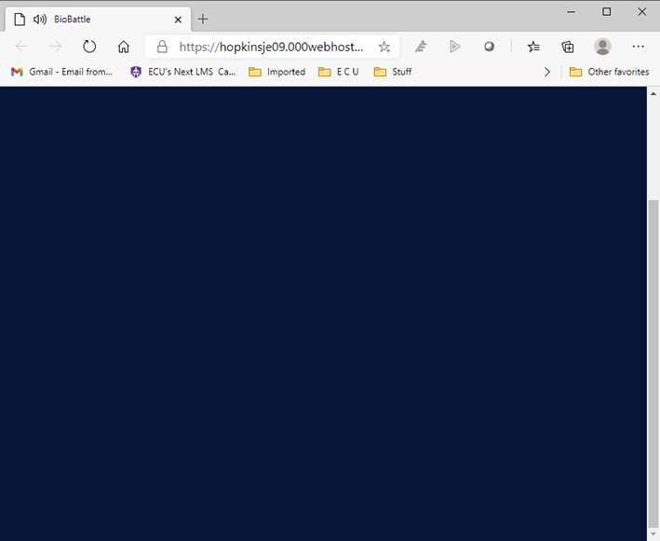

**From:** Hopkins, Jeremy <hopkinsje09@students.ecu.edu>   
**Sent:** Tuesday, November 10, 2020 3:25 PM  
**To:** Moffett, Virgil Dean, Sr <moffettv20@students.ecu.edu>; Little, Mark Douglas <littlema20@students.ecu.edu>; Bartshe, Steven <bartshes16@students.ecu.edu>  
**Subject:** Re: Team project SARS Game

Hit F12 to go to developer tools and let me know if you see any errors in the console.

**From:** Moffett, Virgil Dean, Sr   
**Sent:** Tuesday, November 10, 2020 3:27 PM  
**To:** Hopkins, Jeremy <hopkinsje09@students.ecu.edu>; Little, Mark Douglas <littlema20@students.ecu.edu>; Bartshe, Steven <bartshes16@students.ecu.edu>  
**Subject:** RE: Team project SARS Game



**From:** Moffett, Virgil Dean, Sr   
**Sent:** Tuesday, November 10, 2020 3:33 PM  
**To:** Hopkins, Jeremy <hopkinsje09@students.ecu.edu>; Little, Mark Douglas <littlema20@students.ecu.edu>; Bartshe, Steven <bartshes16@students.ecu.edu>  
**Subject:** Test : Team project SARS Game - Edge and Chrome

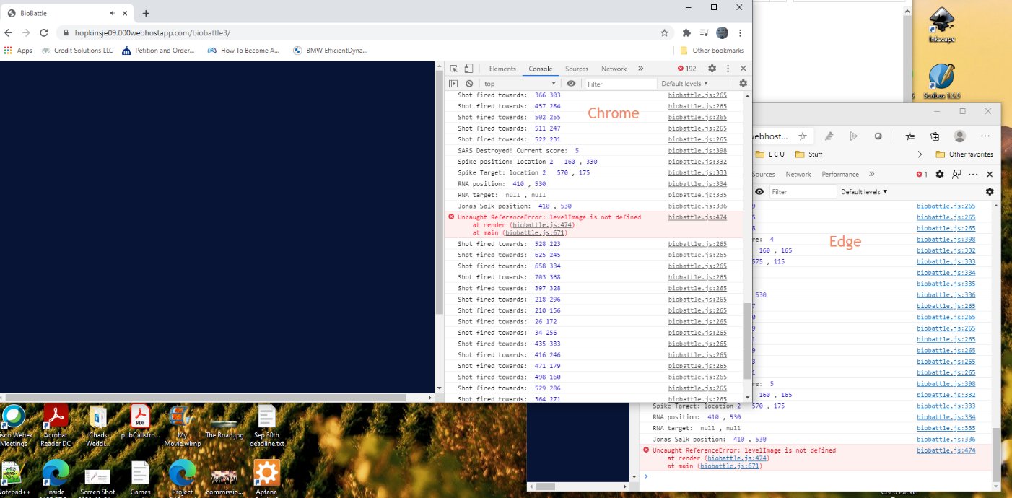

Kind Regards,

Virgil Moffett

**From:** Hopkins, Jeremy <hopkinsje09@students.ecu.edu>   
**Sent:** Tuesday, November 10, 2020 3:34 PM  
**To:** Moffett, Virgil Dean, Sr <moffettv20@students.ecu.edu>; Little, Mark Douglas <littlema20@students.ecu.edu>; Bartshe, Steven <bartshes16@students.ecu.edu>  
**Subject:** Re: Test : Team project SARS Game - Edge and Chrome

Looks like I’m missing the “level up” graphic, I’ll fix, give me a few.

**From:** Moffett, Virgil Dean, Sr   
**Sent:** Tuesday, November 10, 2020 3:40 PM  
**To:** Hopkins, Jeremy <hopkinsje09@students.ecu.edu>; Little, Mark Douglas <littlema20@students.ecu.edu>; Bartshe, Steven <bartshes16@students.ecu.edu>  
**Subject:** RE: Test : Team project SARS Game - Edge and Chrome

From IE11

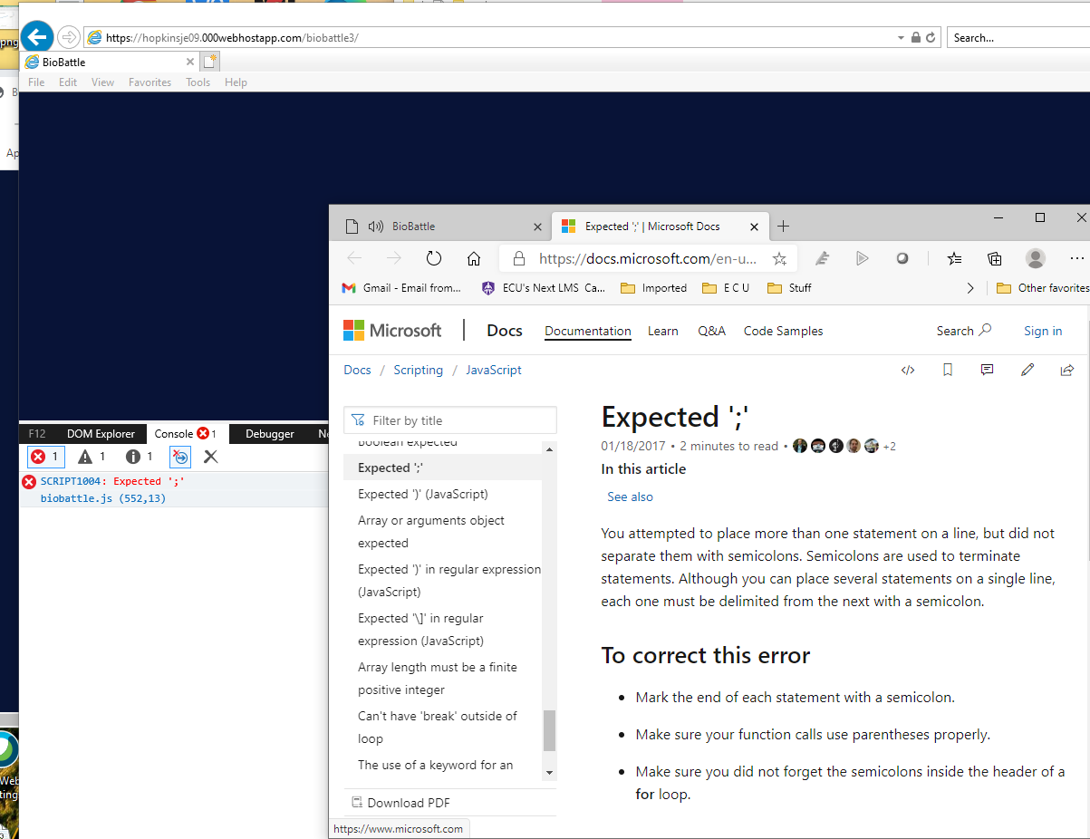

Kind Regards,

Virgil Moffett

**From:** Hopkins, Jeremy <hopkinsje09@students.ecu.edu>   
**Sent:** Tuesday, November 10, 2020 3:49 PM  
**To:** Moffett, Virgil Dean, Sr <moffettv20@students.ecu.edu>; Little, Mark Douglas <littlema20@students.ecu.edu>; Bartshe, Steven <bartshes16@students.ecu.edu>  
**Subject:** Re: Test : Team project SARS Game - Edge and Chrome

The level up issue should be fixed now.  Reload and try again.  Looks like I didn’t include that image or code to load the image when I merged the two versions.

Let me know if you’re still seeing this IE11 bug…

-Jeremy

**From:** Moffett, Virgil Dean, Sr   
**Sent:** Tuesday, November 10, 2020 4:23 PM  
**To:** Hopkins, Jeremy <hopkinsje09@students.ecu.edu>; Little, Mark Douglas <littlema20@students.ecu.edu>; Bartshe, Steven <bartshes16@students.ecu.edu>  
**Subject:** RE: Test : Team project SARS Game - Edge and Chrome

Yes still there…

Edge :

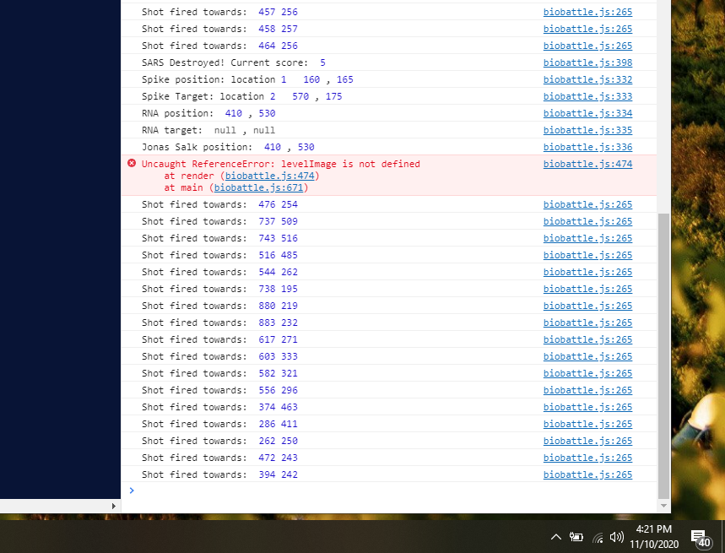

**From:** Moffett, Virgil Dean, Sr   
**Sent:** Tuesday, November 10, 2020 4:23 PM  
**To:** Hopkins, Jeremy <hopkinsje09@students.ecu.edu>; Little, Mark Douglas <littlema20@students.ecu.edu>; Bartshe, Steven <bartshes16@students.ecu.edu>  
**Subject:** RE: Test : Team project SARS Game - Edge and Chrome

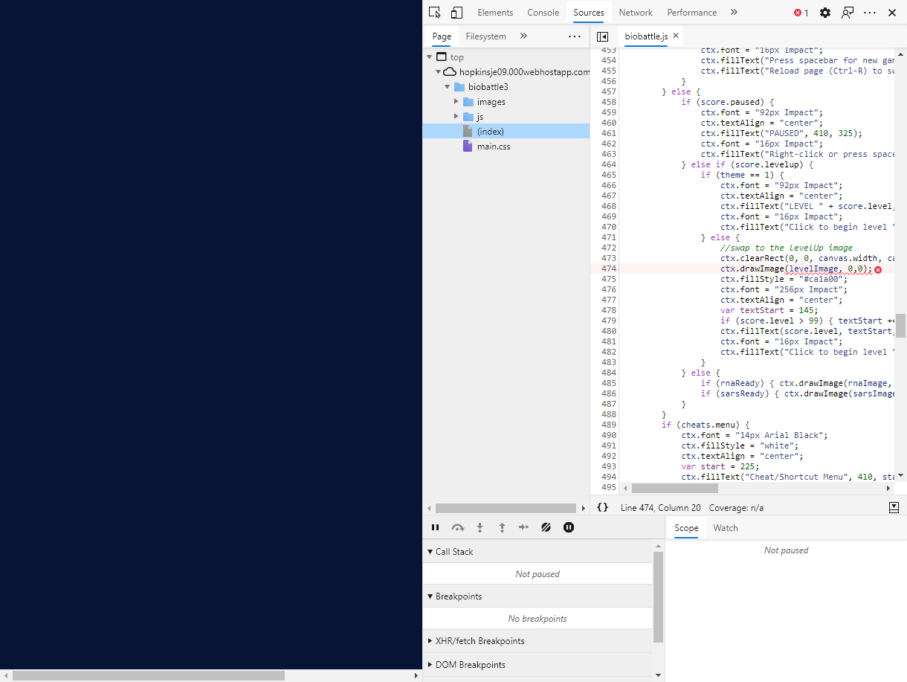

**From:** Hopkins, Jeremy <hopkinsje09@students.ecu.edu>   
**Sent:** Tuesday, November 10, 2020 4:24 PM  
**To:** Moffett, Virgil Dean, Sr <moffettv20@students.ecu.edu>  
**Subject:** Re: Test : Team project SARS Game - Edge and Chrome

Hold down shift and hit reload.   That issue should be fixed now.

**From:** Moffett, Virgil Dean, Sr   
**Sent:** Tuesday, November 10, 2020 4:29 PM  
**To:** Hopkins, Jeremy <hopkinsje09@students.ecu.edu>  
**Subject:** RE: Test : Team project SARS Game - Edge and Chrome

## Yes – working great – except I have a huge “loss of life”

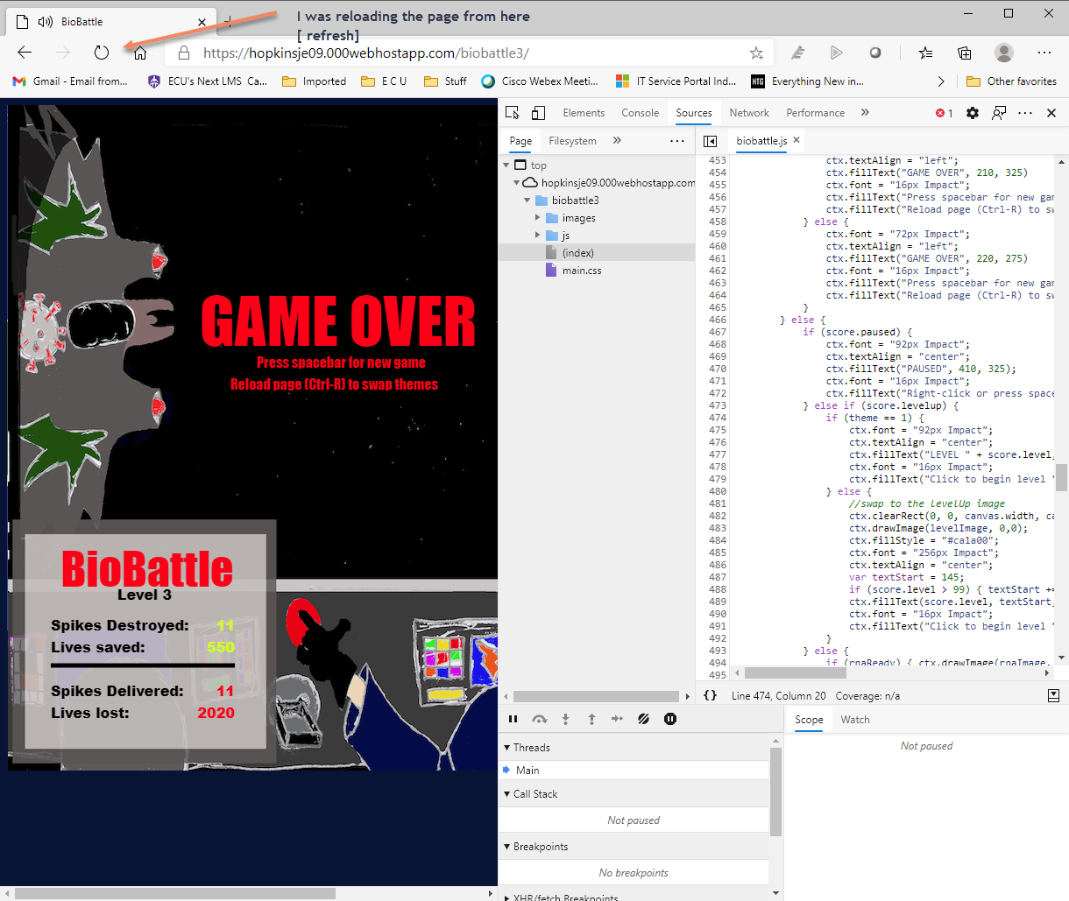

# Game Design Artwork – Mark Little 9-28-2020

*This document is a road map, and will grow and change as the game takes shape. It is meant to serve as a reference for the team, functioning as both an anchor and a compass. The goal is to define a clear scope for the game, and help keep game development on track.*

Game Design ***(****Design gameplay; conceives and designs the rules and structure of the game; develops characters; develops game levels; writes the rules, game narrative and commentary, as well as any text guidance or clues includes in the game interface.)*

Name**:** BioBattle

Core Concept/Plot**:**

From the bridge of the destroyer Jonas Salk, the player is charged with defending planet Earth and its inhabitants from the invading Corona Empire warriors and their SARS (Society Annihilating Replicant Spikes) biological superweapons, which are launched from their battleship Corona Star. The SARS spikes are launched toward the Earth’s atmosphere. If they make it into the lower atmosphere, they will release their biological agents, which will infect and kill millions of Earth’s inhabitants, possibly killing all of mankind.

To defend Earth from the Corona Empire warriors, there are enzyme cannons on the Jonas Salk which launch RNA (Rapidly Neutralizing Antibodies) at rapid speed. The RNAs destroy the SARS spikes fired from the Corona Star.

### Characters

There are two characters; 1) the commander of the Jonas Salk, who defends planet Earth by firing RNA from the enzyme cannons; 2) and the chief the Corona Empire warriors, who is shooting the biological weapon SARS spikes at planet Earth, with the goal of killing all inhabitants.

### Location

The destroyer Jonas Salk is positioned in a geostationary orbit above Earth. The Corona Empire and their Corona Star battleship are firing SARS spikes from space toward the Earth.

Mechanics/features of gameplay**:**

The Corona Star launches SARS spikes at a set interval. These make their way toward Earth. The enzyme cannons on the destroyer Jonas Salk shoot RNA based on keyboard or mouse commands. The RNA destroy the SARS spikes when hit and earn points for the captain of the Jonas Salk.

You earn points for each SARS spike you neutralize with a shot from the RNA cannons. The Corona Start can shoot 50 SARS spike per game. The goal is to earn as high a score as possible by destroying the spikes.

***(We need to determine what happens when a SARS spike makes it to planet Earth. Also, are there levels of difficulty? Does the rate at which SARS spikes launch increase?)***

Genre**:**

FPS – First-person Shooter  
The player takes on the role of the Jonas Salk captain, who must combat waves of SARS spikes fired from the Corona Star.  
  
ESRB rating equivalent: E for everyone  
  
***(How many levels of difficulty should we have?)***

Artwork ***(****Create the visual environment of the game; designs characters, backdrops, terrain, and all user interfaces; designers any animations, 3D graphics or other cinematics)*

The game will be played from the bridge of the destroyer Jonas Salk, as seen from the viewpoint of the commander. The Corona Star fires SARS spikes toward Earth from its position above the north pole. Below is a draft of the interface, showing the various graphics and their relationships to each other. The SARS spikes (fired from Corona Star) are in in red, and the RNA (fired from the Jonas Salk) are in yellow. This is the images that the Jonas Salk commander sees when looking out from the destroyer into space.

***(The RNA and SARS will need to be smaller. I am also thinking of increasing the height of the window, and placing planet Earth and the Corona Star directly across from each other. The SARS spike will go from left to right toward Earth. The RNA will come from under the window, and go toward the SARS spike, hitting them before they get to Earth).***

